MIE1624 | Canada AI Competitiveness Project
Expected Results, Strategic Impact,
Success Metrics & Conclusion
Final Report — Section 4 of 4 (with Success Metrics) | University of Toronto, Winter 2026

5. Expected Results and Strategic Impact

5.1 Canada’s Baseline Position and the Cost of Inaction

Canada enters the projection horizon ranked 5th globally, with a composite AI competitiveness score of 32.86 out of 100. The gap to 4th-ranked Singapore (33.04) is less than one composite point, but it is fragile. The modelled baseline trajectory — reflecting competitive drift from peer nations improving their own positions absent any new Canadian policy action — shows Canada falling to 6th place by mid-2027 and remaining there through 2029 Q4.
The structural driver is a conversion gap, not a strategy gap. Canada’s Government Strategy score is maxed at 100.0 and its Operating Environment score (93.94) is among the strongest in the ranking. Yet the Commercial Ecosystem score stands at 14.88, AI Investment Activity at 3.16, and domestic AI Adoption at 8.0 — all materially below peer-cluster comparators. Sub-pillar scores further illustrate the divide: Commercial Ecosystem (10.27) and Research (28.82) are the weakest pillars, while Government Strategy (100.00) and Operating Environment (69.82) are the strongest. The imbalance defines the strategic challenge.

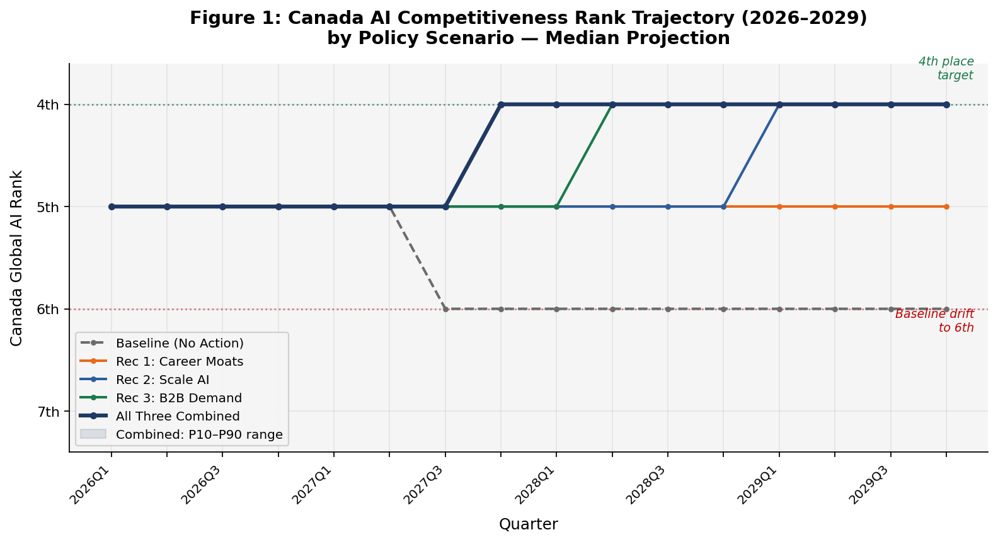
Figure 1: Canada AI Competitiveness Rank Trajectory by Policy Scenario (2026–2029). Median projection; dashed = baseline with no policy action.

5.2 What the Recommendations Are Expected to Achieve

The three recommendations are modelled as stand-alone counterfactuals and as a combined package, over 16 quarters (2026 Q1 – 2029 Q4). Results reflect the median Monte Carlo outcome.

Scenario | End Score | End Rank | Gain vs. Baseline
Baseline — No new policy | 32.86 | 6th | —
Recommendation 1 only – Career Moats | 33.87 | 5th | +1.01
Recommendation 2 only – Scale AI Conditions | 34.42 | 4th | +1.55
Recommendation 3 only – B2B Demand Credits | 34.36 | 4th | +1.49
All Three Recommendations Combined | 36.93 | 4th | +4.07

Table 1: Scenario Comparison — Canada Composite Score and Rank at End of Horizon (2029 Q4)

The combined scenario locks in a 4th-place ranking by the end of 2027 Q4 — approximately 18 months into the implementation horizon. Stand-alone Recommendations 2 and 3 each reach 4th place, but not until mid-to-late 2028. Recommendation 1 alone prevents the baseline deterioration to 6th but does not reach 4th within the modelled period. The combined composite gain of approximately 4.07 points reflects meaningful complementarity: the three levers reinforce one another across talent, commercialization, and demand channels.

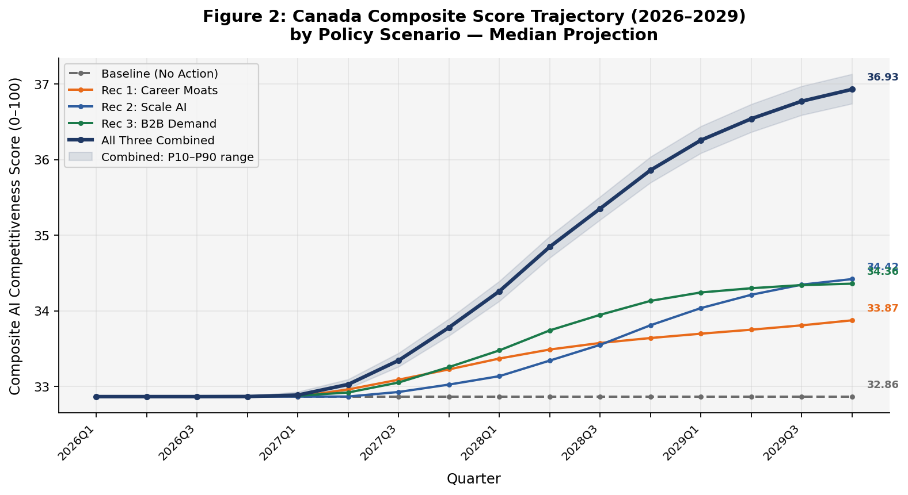
Figure 2: Canada Composite Score Trajectory by Scenario (2026–2029). Shaded band = P10–P90 uncertainty range for the combined scenario.

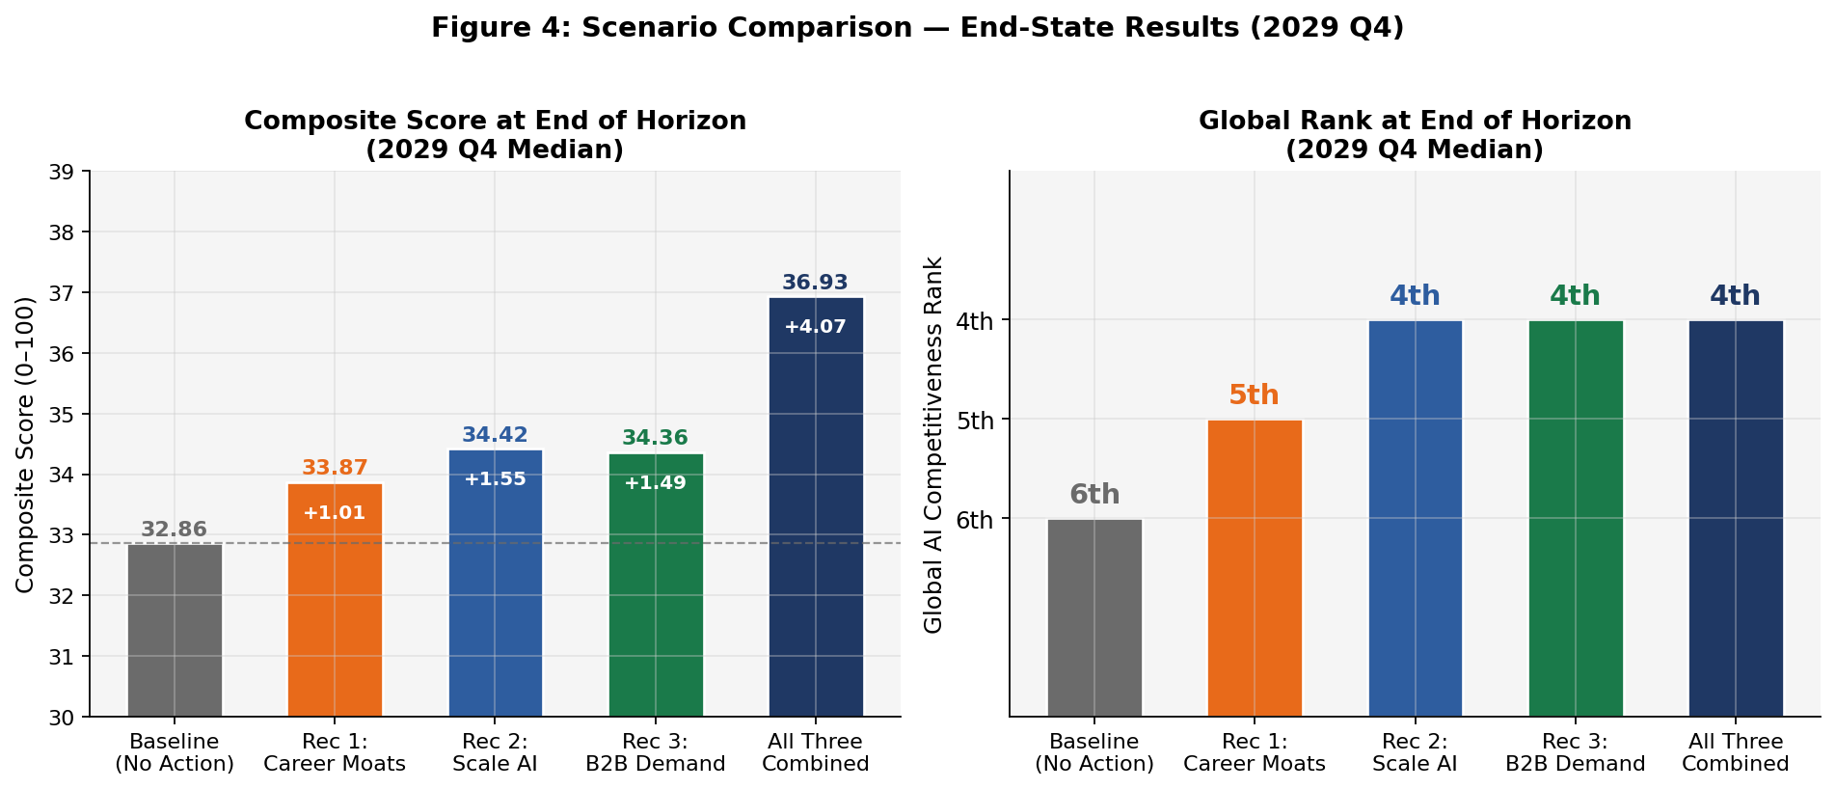
Figure 4: End-State Scenario Comparison — Composite Score (left) and Global Rank (right) at 2029 Q4.

5.3 KPI-Level Impact: What Changes, and Where

Recommendation 1 — Build Career Moats for Talent targets talent retention and attraction KPIs most directly. Tortoise Talent Score improves ~4.66 points (>55% peer-gap closure vs. UK), AI Hiring Rate +3.73 pts (~14% global-best gap closure), and Net Migration Flow +3.57 pts. AI Job Postings improve ~2.76 pts. Modest downstream commercial gains (+0.83 pts) emerge as retained talent supports early commercialization activity.
Recommendation 2 — Build the Conditions to Scale AI in Canada produces the largest commercial and investment KPI improvements. The Tortoise Commercial Score improves ~8.50 points (100% peer-gap closure vs. UK), AI Investment Activity +6.17 pts (100% peer-gap closure), and AI Adoption +2.12 pts. Development Score rises modestly (+0.63 pts) as scale-up vehicles begin generating commercial IP.
Recommendation 3 — Stimulate B2B Demand via Adoption Credits has the strongest impact on AI Adoption (+5.72 pts; ~48% peer-gap closure), Tortoise Commercial Score (+7.63 pts; full peer-gap closure), and AI Investment Activity (+4.88 pts). Patent Grants improve +0.63 pts as first-customer adoption mandates incentivize domestic productization.
In the combined scenario: Tortoise Commercial Score +17.0 pts; AI Investment Activity +11.1 pts; AI Job Postings +9.6 pts; AI Adoption +7.8 pts; Net Migration Flow +6.2 pts. Research and Development scores improve modestly; Infrastructure remains unchanged, as expected given the scope of the three recommendations.

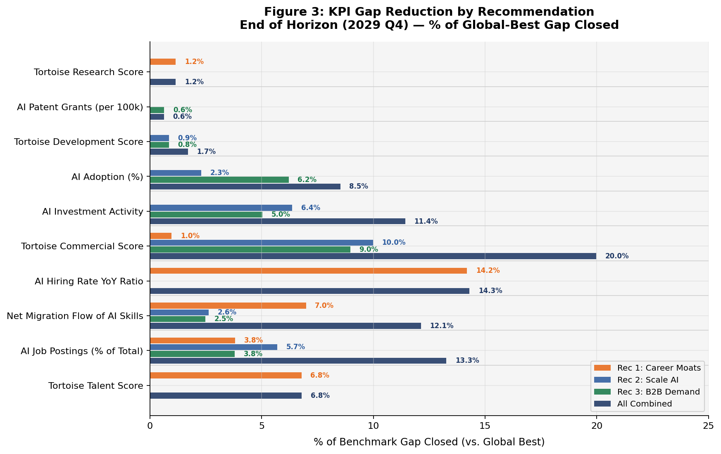
Figure 3: KPI Gap Reduction by Recommendation — % of Global-Best Gap Closed at End of Horizon (2029 Q4).

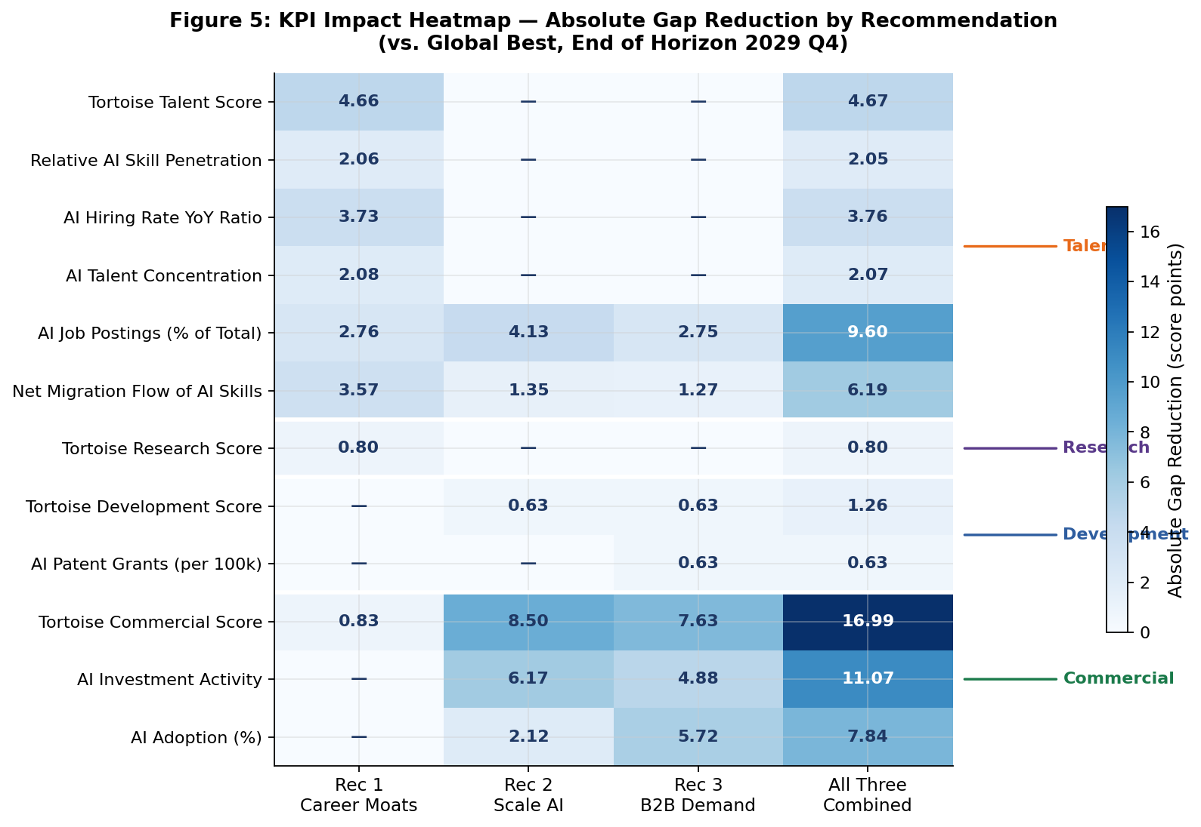
Figure 5: KPI Impact Heatmap — Absolute Gap Reduction by Recommendation (score points vs. global best, 2029 Q4).

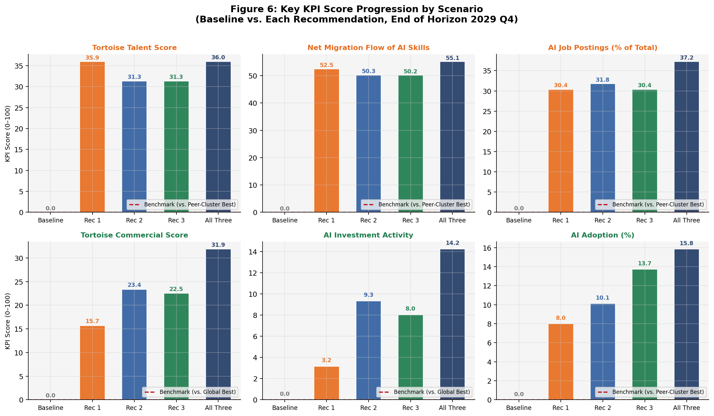
Figure 6: Key KPI Score Progression by Scenario — Baseline vs. Each Recommendation (2029 Q4). Red dashed = benchmark target.

5.4 Operational Success and Early Indicators

Operational success should be evaluated against leading indicators observable before composite rank movements become visible.

- Talent retention: Net migration flow stabilizing or turning positive within four to six quarters of Recommendation 1 launch.
- Labour market demand: AI Job Postings rising within two to three quarters as employer incentives activate.
- Commercialization pipeline: Series B/C funding rounds increasing within four to six quarters of Recommendation 2’s co-investment vehicles becoming operational.
- Adoption uptake: First-customer adoption credit claims rising within two to four quarters of Recommendation 3’s launch.
- Composite score: A gain of approximately 1.0–1.5 points above baseline should be observable by 2027 Q3–2027 Q4 if all three recommendations are on schedule.

5.5 Success Metrics per Recommendation

Tracking implementation success requires metrics that are concrete, observable within the programme’s operational lifespan, and directly tied to the intended mechanism of each recommendation. The five success metrics below are drawn from the project’s source materials and federal programme analogues. They complement the KPI-level indicators by providing ground-level operational signals that confirm whether each policy lever is functioning as designed, before composite score movements become statistically visible.
Each metric is defined by a 2024–25 federal baseline and a programme-specific target. The baselines use the best available proxy from federal reporting (primarily Innovative Solutions Canada’s Pathway to Commercialization programme) where AI-specific programme data does not yet exist. Confidence is rated medium across all five metrics, reflecting the reliance on analogues rather than AI-specific predecessor programmes.
5.5.1 Recommendation 1: Build Career Moats for Talent

The primary success metric for Recommendation 1 measures the degree to which the retention and attraction levers — the equity tax exemption, the 1:1 salary-matching tax credit, and the AI Elite fast-track visa/PR stream — reduce the rate at which supported firms lose core AI staff. This is an implementation-level retention metric, not a competitiveness KPI; it captures whether the financial and immigration instruments are actually changing the retention calculus for targeted talent.

Recommendation 1 — Career Moats for Talent Retention
Metric | Current (Baseline) | Target | Timeline
Core AI Team Attrition (Supported Firms) | 20% of core AI staff leaving (2024) | ≤15% attrition | 24–36 months post-launch

A reduction in core AI team attrition from 20% to at or below 15% within two to three years would represent a 25% improvement in retention rates. This threshold is consistent with the programme rationale: the recommendation aims to make Canada competitive at the margin with US and UK alternatives, not to eliminate all outflows. The metric should be monitored across the subset of firms participating in the retention programme rather than the broader sector, to isolate programme effect from ambient labour market conditions.
Early signals of progress will include: uptake rates for the equity tax exemption programme, number of AI Elite fast-track applications filed and approved per quarter, and employer-reported changes in offer acceptance rates for senior AI hires. These leading indicators should be tracked from Q1 2026 onward, ahead of the 24-to-36-month formal retention metric checkpoint.
5.5.2 Recommendation 2: Build the Conditions to Scale AI in Canada

Recommendation 2’s success metric focuses on the commercialization conversion rate: specifically, whether the subsidized pilots created through the federal procurement challenge and the co-investment vehicles successfully convert into self-sustaining paid commercial contracts. This metric captures the most critical failure point in the Canadian AI commercialization pipeline — the transition from pilot-stage validation to revenue-generating, repeatable commercial relationships.

Recommendation 2 — Scale AI Conditions (Compute, Capital, Procurement)
Metric | Current (Baseline) | Target | Timeline
Subsidized Pilots Converting to Paid Commercial Contracts | ~25% conversion rate  (FY2024–25 federal analogue) | 50%+ conversion rate | 18 months post-launch

The 25% baseline is proxied from Innovative Solutions Canada’s Pathway to Commercialization programme (11 contracts from 44 eligible innovations in 2024–25) and is not AI-specific. The target of 50%+ within 18 months is intentionally ambitious: it reflects the combined effect of compute subsidies reducing the cost barrier to piloting, growth-stage co-investment increasing firms’ capacity to sustain commercial relationships, and the procurement challenge providing a structured conversion pathway from government pilot to commercial contract.
If conversion rates remain near the 25% baseline at the 18-month checkpoint, it would indicate that the demand-side channel (procurement matching) is underperforming relative to the capital-side channel — signalling a need to review either the procurement challenge design or the eligibility criteria for co-investment. The metric should be disaggregated by firm size and sector to identify whether conversion challenges are concentrated in specific segments.
5.5.3 Recommendation 3: Stimulate B2B Demand via Adoption Credits

Recommendation 3 has three success metrics reflecting the three distinct phases of its implementation: building the supply-side registry of eligible AI scale-ups before launch, securing pre-launch procurement commitments from institutional AnchorAdopters, and tracking the ongoing conversion of adoption-credit-subsidized deployments into durable multi-year commercial relationships.

Recommendation 3 — B2B Demand via Adoption Credits
Metric | Current (Baseline) | Target | Timeline
Pre-Qualified Canadian AI Scale-Ups in Launch Registry | 44 companies  (FY2024–25 analogue) | 200+ companies | At programme launch
Pre-Launch Procurement Deals (AnchorAdopter Programme) | 11 deals  (FY2024–25 analogue) | 25–40 deals | Pre-launch pilot phase
Credit-Subsidized Deployments Converting to Multi-Year Contracts | ~25% conversion rate  (FY2024–25 federal analogue) | 50%+ conversion rate | 18 months post-launch

The registry target of 200+ pre-qualified Canadian AI scale-ups at programme launch is essential for establishing supply-side depth: without a sufficient number of eligible suppliers, the adoption credit will stimulate demand that gets met by foreign AI products rather than Canadian ones, defeating the programme’s competitiveness rationale. The IP eligibility rules and Canadian-ownership criteria are the enforcement mechanism for this outcome.
The AnchorAdopter pre-launch deal target of 25–40 signed procurement commitments creates demand certainty before the credit window opens, reducing the risk that adoption decisions are dominated by larger, incumbent technology vendors rather than emerging Canadian AI firms. The 18-month contract conversion rate target mirrors that of Recommendation 2 and should be monitored with clawback enforcement as a proxy for programme integrity.
If the registry build falls significantly short of 200 companies at launch, it signals a supply-side constraint that may require adjusting IP eligibility rules or expanding the definition of qualifying Canadian AI firms. If AnchorAdopter deal volumes fall short of the pre-launch range, it suggests that institutional buyers require additional incentive design changes to commit before the credit window opens formally.
5.5.4 Consolidated Success Metrics Summary

The five metrics below consolidate all three recommendations into a single monitoring framework. Progress against these metrics, tracked on a quarterly cadence, provides the earliest observable signal that the implementation strategy is on track before rank and composite score movements become visible in the model outputs.

Metric & Recommendation | Baseline → Target | Horizon & Confidence
Core AI Team Attrition (Rec 1: Career Moats) | 20% → ≤15% attrition | 24–36 months | Medium confidence
Pilot-to-Contract Conversion Rate (Rec 2: Scale AI) | 25% → 50%+ conversion | 18 months | Medium confidence
Credit-Deployment-to-Contract Conversion (Rec 3: B2B Demand) | 25% → 50%+ conversion | 18 months | Medium confidence
AI Scale-Ups in Launch Registry (Rec 3: B2B Demand) | 44 → 200+ companies | At programme launch | Medium confidence
AnchorAdopter Pre-Launch Deals (Rec 3: B2B Demand) | 11 → 25–40 deals | Pre-launch pilot phase | Medium confidence

Table 2: Consolidated Success Metrics — All Three Recommendations

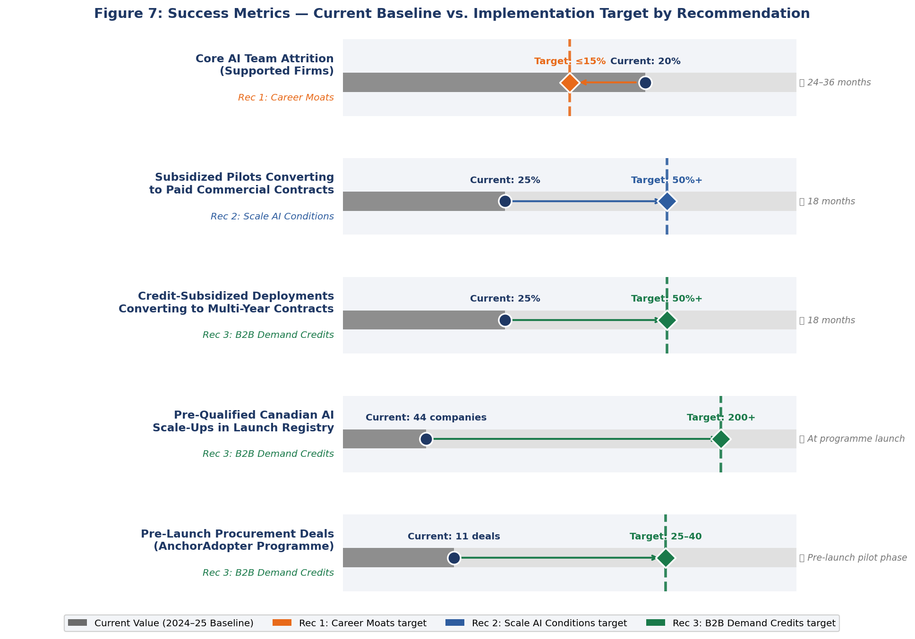
Figure 7: Success Metrics — Current Baseline vs. Implementation Target by Recommendation. Diamond markers = targets; circle markers = current values. Timeline shown on right.

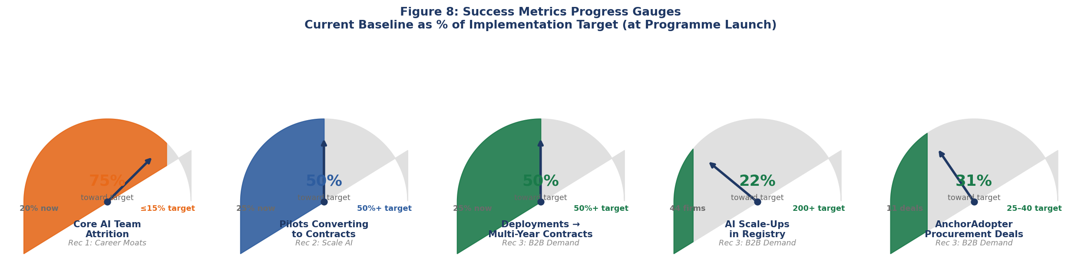
Figure 8: Success Metrics Progress Gauges — Current baseline as % of implementation target at programme launch.

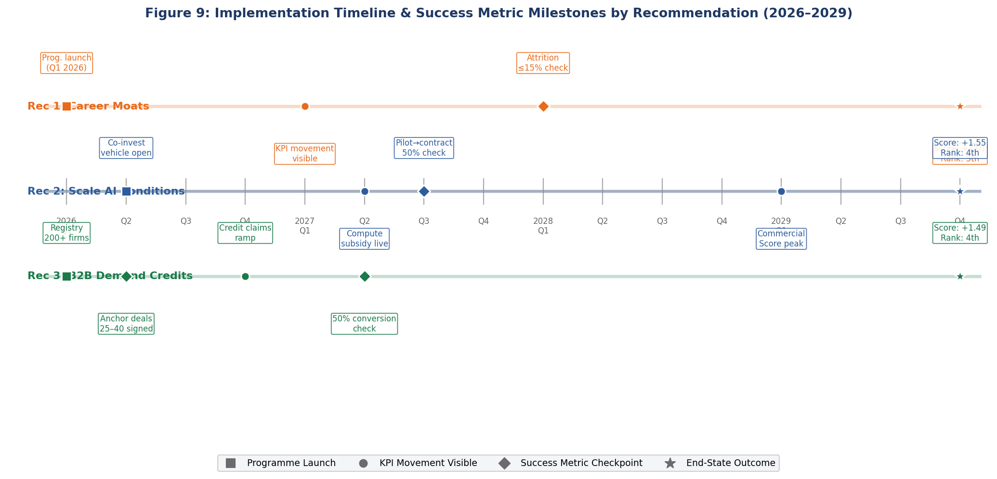
Figure 9: Implementation Timeline & Success Metric Milestones by Recommendation (2026–2029). ■ = Programme Launch ● = KPI Movement ◆ = Success Metric Checkpoint ★ = End-State Outcome.

Interpretation Guidance — Success Metrics
The five success metrics are operational proxies, not primary competitiveness KPIs. They are designed to signal whether each recommendation’s core mechanism is working — independent of composite score movements that typically lag by two to four quarters. Baselines use FY2024–25 federal programme analogues (Innovative Solutions Canada’s Pathway to Commercialization) rather than AI-specific predecessor data; this limits precision but does not undermine directional validity. A medium confidence rating is assigned to all five metrics, reflecting reliance on analogues. Decision-makers should treat missed metric thresholds as early warning signals requiring programme design review, not as evidence of strategy failure.

6. Strategic Interpretation of Results

The modelled results are best understood not as a forecast but as a structured assessment of what becomes possible if Canada acts, and what is likely to happen if it does not. The central projection represents a realistic, policy-informed trajectory under the median Monte Carlo outcome — not a guarantee, but a grounded basis for strategic decision-making.
The most important strategic insight is directional: Canada’s competitiveness gap is not primarily a resource or infrastructure gap. It is a conversion gap. Canada holds a maxed Government Strategy score and near-maxed Operating Environment score. Its research community produces internationally recognized work. The problem is that this strength does not convert into retained talent, scaled commercial firms, or demonstrated domestic AI adoption at a rate commensurate with a 5th-place economy.
The three recommendations are specifically calibrated to address that conversion failure. Recommendation 1 addresses the exit problem at the talent stage. Recommendation 2 addresses the scale problem at the commercialization stage. Recommendation 3 addresses the demand problem at the market activation stage. Together, they close the loop: talent stays, firms scale, and domestic demand validates and accelerates the cycle.
The success metrics in Section 5.5 are the operational expression of that theory of change. A falling attrition rate confirms that Recommendation 1 is changing retention calculus. Rising pilot-to-contract conversion rates confirm that Recommendation 2 is activating the commercialization pipeline. Registry depth, AnchorAdopter deal volumes, and deployment conversion rates confirm that Recommendation 3 is generating durable domestic demand rather than one-off subsidized pilots. These metrics are the bridge between policy intent and measurable competitiveness impact.
The results are realistic in their modelled magnitude. The combined composite gain of approximately 4.07 points represents a 12% improvement above Canada’s baseline score — meaningful, but consistent with what comparable international precedents suggest is achievable for a coordinated three-to-four year policy package of this scope.

7. Conclusion

Canada occupies a paradoxical position in the global AI landscape. It has the policy architecture of a leading nation — a perfect Government Strategy score, a strong regulatory environment, and internationally respected research institutions — but the commercial and talent outcomes of a country still trying to convert that architecture into economic results. The central argument of this analysis is that the gap is not strategic ambition: it is execution in three specific, addressable areas.
The three recommended actions — Career Moats for Talent Retention, Conditions to Scale AI Firms, and B2B Demand Stimulus via Adoption Credits — were selected because they address the most consequential conversion failures in the Canadian AI ecosystem, are bounded within federal authority and budget capacity, and are calibrated against demonstrated international experience. Together, they form a reinforcing package: talent stays, firms have vehicles to scale, and domestic demand validates the cycle.
The modelled results support this prioritization. Implemented together, the package is projected to raise Canada’s composite AI competitiveness score from 32.86 to approximately 36.93 by end of 2029 — a gain of roughly 4.07 points, or a 12% improvement above baseline. Canada’s rank is projected to move from a deteriorating 6th under no-action to a stable 4th by the end of 2027, maintained through end of horizon. The five success metrics defined in Section 5.5 provide the operational checkpoints for confirming implementation health well before those rank movements materialize.
Canada does not need to outspend the United States or outscale China to materially improve its competitive position. It needs to close specific, bounded gaps in talent conversion, commercial scale-up capacity, and domestic market demand — gaps that are measurable, trackable, and addressable with the policy instruments already within federal reach. If implemented with fidelity and monitored against the leading indicators and success metrics identified in this analysis, Canada is well-positioned to consolidate and extend its standing as one of the top four AI economies in the world. The window to act is open.

8. Limitations and Interpretation Caution

The projected results are scenario-based estimates, not point forecasts, derived from a quarterly simulation model calibrated against structural priors and comparable international experience. Four cautions apply.
First, stand-alone scenario results are counterfactual estimates against a frozen baseline. They are not strictly additive: the three recommendations share overlapping KPI targets, interact over time, and may move the same outcomes through different channels. The combined scenario is the primary strategic projection.
Second, the central projection reflects the median Monte Carlo outcome. The model quantifies uncertainty as an interquartile range. Outcomes at the upper and lower bounds remain possible depending on implementation quality and competitive responses from peer nations.
Third, the model benchmarks Canada against its natural peer cluster (UK, Germany, France, Spain) as the headline comparator. Global-best benchmarks are used where the peer cluster is structurally weak. Using global-best for all KPIs would overstate Canada’s gap and produce implausible near-term targets.
Fourth, success metric baselines rely on federal programme analogues (Innovative Solutions Canada’s Pathway to Commercialization) rather than AI-specific predecessor programmes, given the absence of directly comparable data. This limits precision but does not undermine directional validity. Decision-makers should interpret missed metric thresholds as early warning signals requiring programme design review rather than evidence of strategy failure.

Key Interpretation Note
Each recommendation is presented as a separate stand-alone counterfactual against the same Canada baseline. Effects are not additive. The combined scenario is the primary strategic projection; stand-alone results illustrate attribution, not a summable total. Success metrics are operational proxies with medium confidence; they are designed for early detection, not precise causal attribution.

End of Section | MIE1624 Canada AI Competitiveness Project | University of Toronto, Winter 2026

